Walk 2 Eaton Bishop and Ruckhall
Last walked in February 2017

Description. An 8 km (5 mile) fairly strenuous walk that cannot be completed if the river Wye is in flood. You walk thru trees and along field paths. Walk along a brook and along the river Wye, passing an area of a hill fort.
Start. Park the car by the side of the road opposite the cemetery in Eaton Bishop. Explorer Map 189 Grid 444391.
Direction from Tesco’s roundabout (Turn milometer to zero). Take the A465 Abergavenny road. At the second turning on the R, after point eight of a mile, TR towards Madley. After 3.7 miles TR for Eaton Bishop and St Michael’s Church. After 4.4 miles, (across the road from the church cemetery), park in the small lay-by on your R.

1. St Michael and All Angels’ Church. The church of St Michael and All Angels dates from the 11th Century with a tower containing six bells added in the 12th Century. The Victorians tiled the floor of the chancel, when the original tombstones were moved into the vestry. The East window has one of the oldest complete examples of a medieval stained glass window in the country installed circa 1320. With you’re back to the cemetery TR and go back along the road you came from. Go out of the village and down the road to where the road bends R, you go straight ahead and across a stile/metal gate into a huge crop field F1. Continue in the same directions and cross the field, under electric cables and head to the L of a farm building in front. 100m to the L of the buildings you cross over a stile. Go thru a paddock and then thru a steel gate onto the road. Cross straight ahead into hedge-lined lane (|Unsuitable for Long or Wide Vehicles). Follow the lane for about half a kilometre, passing a house on your R, and just before the lane bends to the R, by a large building and a detached garage, TL and go over a footbridge that’s over the Cage Brook and follow a fenced footpath.

2. Cage Brook. Keeping to the brook on your R, cross a wooden footbridge and continue on with the brook now on your L and wind thru the woods until you go thru a small metal kissing gate onto a road. TL and walk along the road, and just past the bridge you TR to walk down nine concrete steps into woods, the brook is now on your R. Follow track going along the river, past an old Mill, then cross a sloping footbridge. Move down to the R and follow the brook that is on your R. Just underneath power lines you cross over a stile, TL, cross over another stile into F2 and TR, follow the stream on your R. Go over a stile underneath another set of power lines into F3, continue in the same direction. Go over a small gate into F4, and continue on. Cross over a stile into F5, which is situated below New Barns Farm (L). As the stream goes off R, you go straight across the field and over a stile/metal gate onto a road.

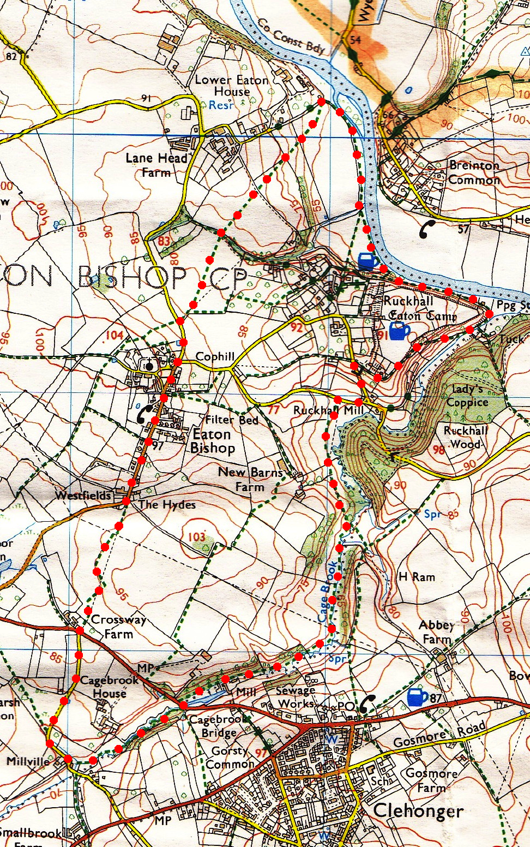
3. Eaton Bishop to Ruckhall road. TR, a short distance along the road you TL at the junction for Ruckhall. As you walk up the road you pass a drive on your R to Bank House, a drive on your L to Sunny Bank, and just before the road levels, turn very sharply to the R and head towards Hill Fort House. As the drive bends L towards the house you go straight on along a green lane. A little further on your L, you can climb up the 11 new steps to view the highest part of the 18-acre hill-fort of Eaton Camp at Ruckhall. Go thru metal gate and along and down below the eastern rampart across a stile onto a gravel drive. TL, walk along the drive, when the drive bends R into the house, you carry straight on and go thru a wooden kissing gate/metal gate into a field. Continue on for 60m. TL in front of enclosure, then fork R down along the riverbank and cross a stile into trees. After 50m TL and go up 11 steps, TR and after 150m go up 33 more steps, TR to go back down 22 more steps. TL to reach the junction below old Ancient Camp Inn that is on your L and was once a pub/restaurant.
5
4
4. Below Ancient Camp Inn. TR and go down about steep stepped path (60 to 70 steps) heading towards the river and Bogwell Pool. TL, go over a stile into F6 and follow the riverbank for 250m. Cross a stile that’s under trees, then over a concrete footbridge, keep R and continue across three-plank bridge, possibly awkward terrain, and reach Sugwas Island on your R. Emerge into a field (F7) that was at the site of the old ferry.
1
3

5. Lower Eaton House area. TL in front of a thatched house, pass thru metal barrier and go up byway. After 60m TL and go thru a kissing gate into F8. Turn diagonally R and walk across the corner of the field to cross over a stile into F9. Continue in the same direction to cross over another stile into F10. Continue up hill to pass thru a kissing gate and over a surfaced cross track at the crest and into F11. Continue in the same direction to descend the field and go over a stile and footbridge over a ditch. Go up crop field (F12) and thru a gateway on to a road. TL for Eaton Bishop and after a short distance you arrive at the car.

2

